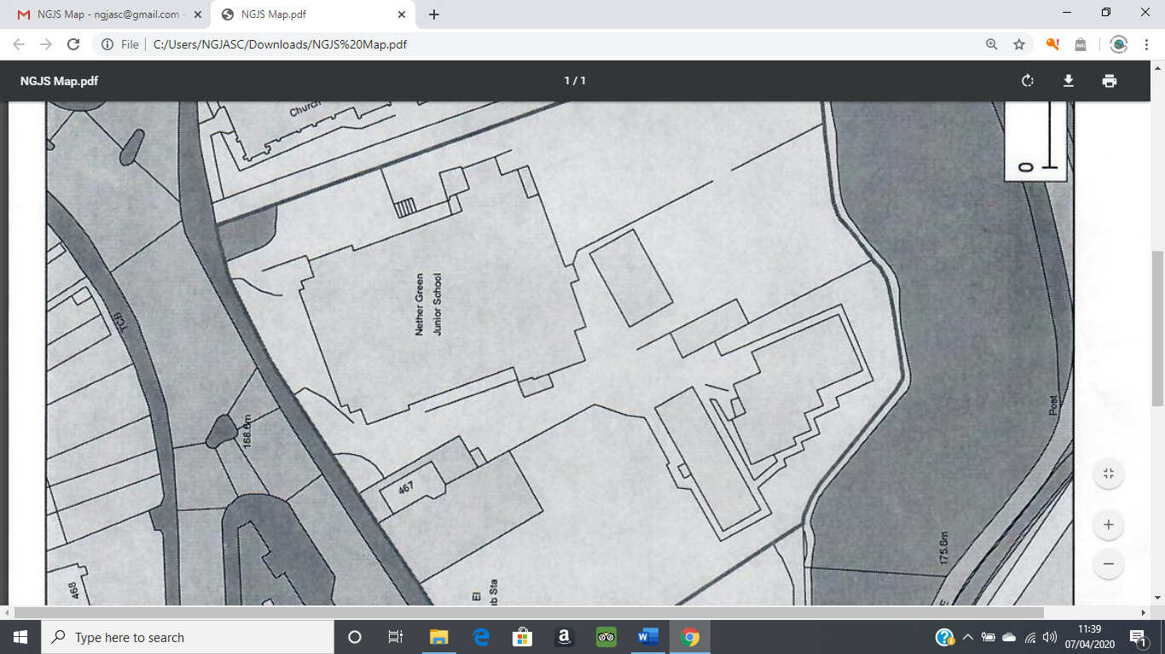

To get to us, please follow the arrows below. We open at 7.15am and close at 6pm.

**BC**

School Office

Staff Car Park

Dinner Hall

**ASC**

Big Yard

Play Trail

Sports hall

Green Room

Small Yard